Build Your Knowledge Graph with myKG and Connect It to Claude Desktop



Senol Isci, Ph.D.
Follow
6 min read
·
Jul 7, 2026
81
3
1
I have recently built and launched myKG! It is an open-source tool that constructs a knowledge graph from a directory of documents, grounds it with an induced schema, and serves it through the Model Context Protocol (MCP). The result is a knowledge base that your AI assistant can navigate, tracing connections across your corpus, answering deeper questions, and showing the evidence behind each answer.
myKG is a cross-platform tool and can connect to any AI application that supports MCP. This walkthrough demonstrates the process using Claude Desktop on MacOS to query a graph built from a small demo corpus.
Press enter or click to view image in full size
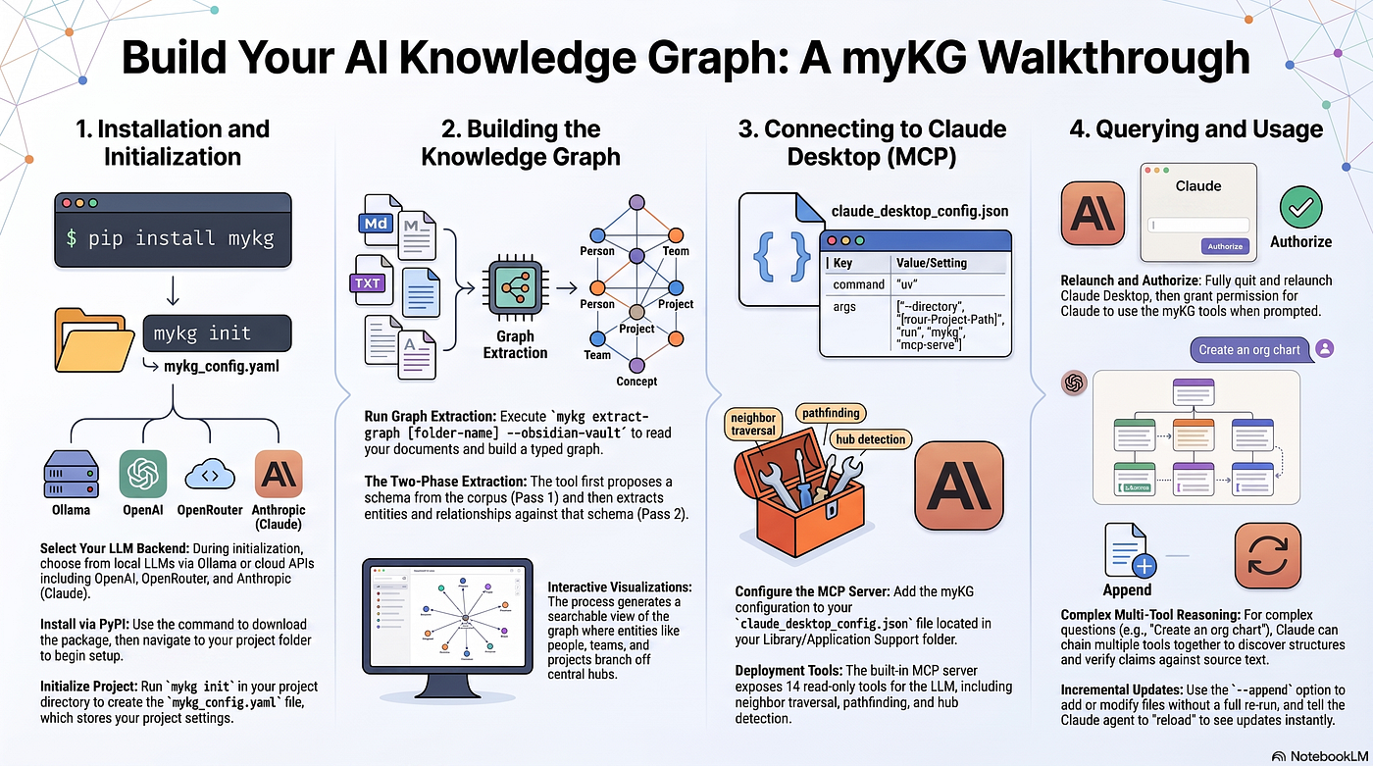

Install and initialize
myKG installs from PyPI:
pip install mykg
Go to the project folder first, then run init from there. For this walkthrough that's a folder on the Desktop with a notes/ subfolder holding the source Markdown files (here). myKG sets up a project and writes mykg_config.yaml into the working directory:
cd ~/Desktop/mykg-project/
mykg init
myKG requires an LLM backend. It currently supports local LLMs via Ollama, along with cloud-based APIs from OpenAI, OpenRouter, and Anthropic. You can configure it during initialization interactively or by editing the configuration file (mykg_config.yaml) in the project folder after the initialization. The initwizard asks which LLM profile to use:
Press enter or click to view image in full size
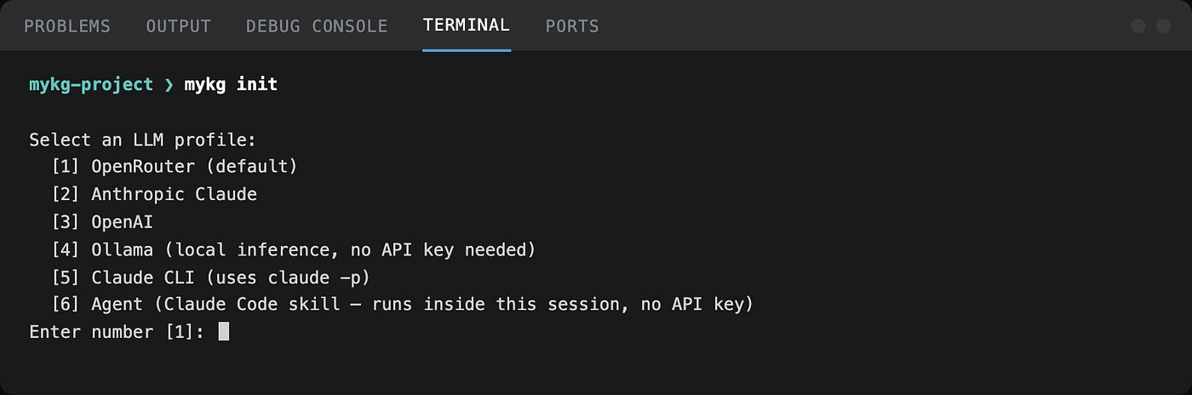
Profile 2 is Anthropic Claude, the one this walkthrough uses. Next, the model name, with a sensible default already filled in.
Then, it asks for an API key (please note that this prompt does not mask its input):
Press enter or click to view image in full size
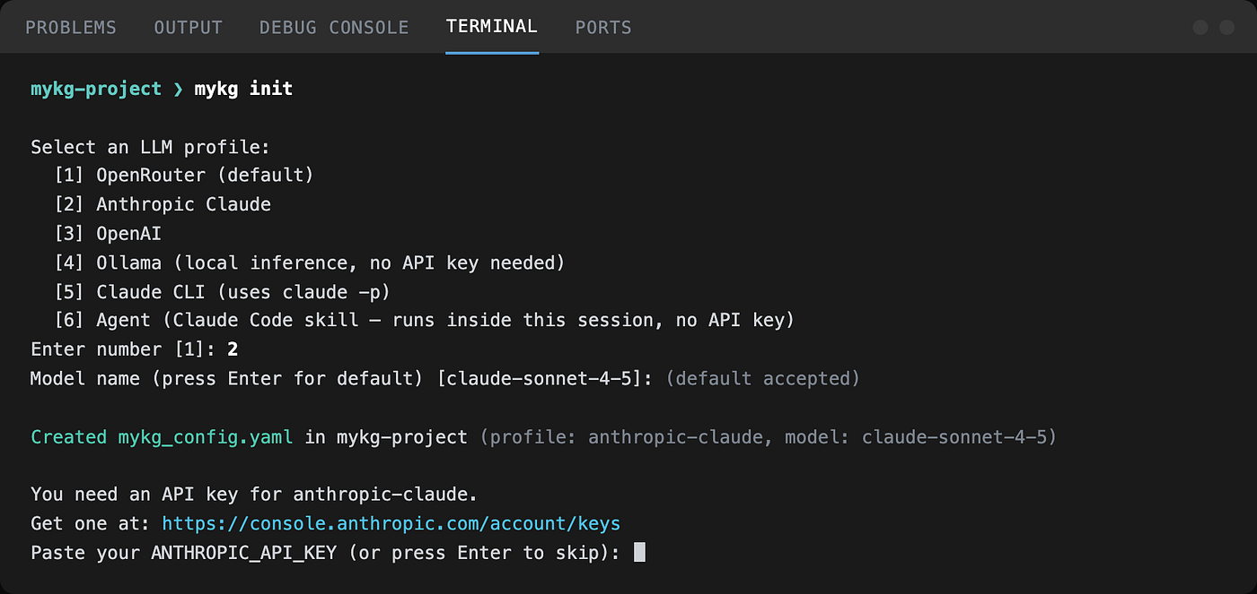

Extracting a graph
The notes/ folder for this walkthrough is four files describing a fictional company, Acme Corp: who’s on the team, which projects are active, which partners are involved, and what technologies are in use (Demo files are here). myKG reads all of them and builds a typed graph:
mykg extract-graph notes/ --obsidian-vault
--obsidian-vault writes the graph out as linked Wiki notes. Please note that this is an Obsidian compliant vault, and you don’t need to install Obsidian application to use it in myKG.
The run has two phases: Pass 1 proposes a schema from the corpus, Pass 2 extracts entities and relationships against it. The run also generates an interactive, searchable view of the knowledge graph. Acme Corp sits as the hub, with named people, teams, and projects branching off it:
Press enter or click to view image in full size
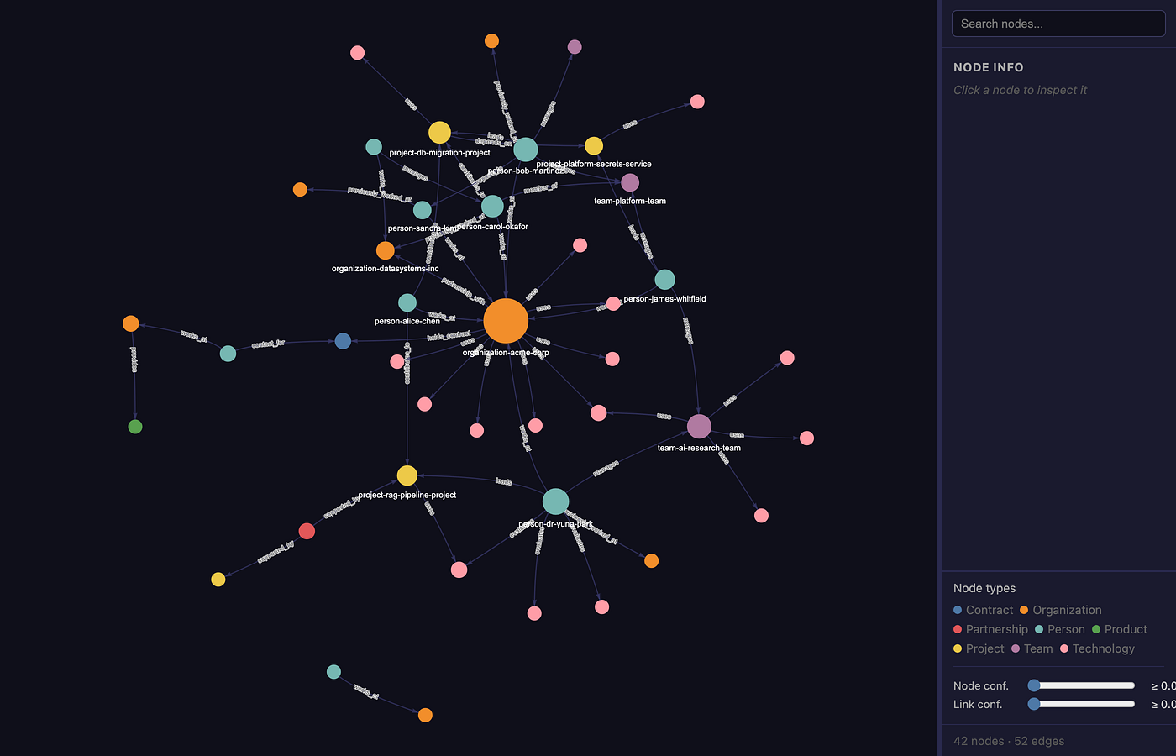
The demo files finished in under one minute, but processing time and cost scale with file size, file type, LLM provider, batch token targets, and concurrency. Costs can increase quickly when running at scale on a paid API plan. Please read the configuration options in the README, and test on a small subset of your files before pointing myKG at a full corpus.
You can add new files or modify existing ones, and update the graph incrementally with the --append option, without a full re-run over the whole corpus. Details are in the README.

Serving the graph over MCP
myKG has a built-in MCP server that runs over stdio, the same transport protocol Claude Desktop uses to talk to local tools. It exposes 14 read-only tools for querying the graph, search, node lookup, neighbor and path traversal, schema and stats access, reloading the knowle graph, hub/orphan detection, and reading Obsidian vault notes, so an LLM client can explore the graph rather than just receive a dump of it. If you have updated the knowledge graph, just tell Claude agent in the chat, and then it will reload it without leaving the chat.
Please note that myKG MCP Server is a standard-compliant FastMCP implementation. Therefore, it can connect to any AI chatbot application that supports MCP.

Wiring it into Claude Desktop
Claude Desktop reads its MCP server list from a config file at ~/Library/Application Support/Claude/claude_desktop_config.json. Please add the following to the config file:
{
"mcpServers": {
"mykg": {
"command": "uv",
"args": [
"--directory",
"/Users/YourName/Desktop/mykg-project",
"run",
"mykg",
"mcp-serve"
]
}
}
}
Edit the --directory path to point at your own project folder.
You need to do a full quit and relaunch of Claude Desktop for the change to take effect, a window close isn’t enough.

Querying the graph
After connecting, myKG’s MCP tools are available in any Claude Desktop chat, ready to answer questions like “my knowledge graph’s stats” with graph technical jargon straight from the session:
Press enter or click to view image in full size
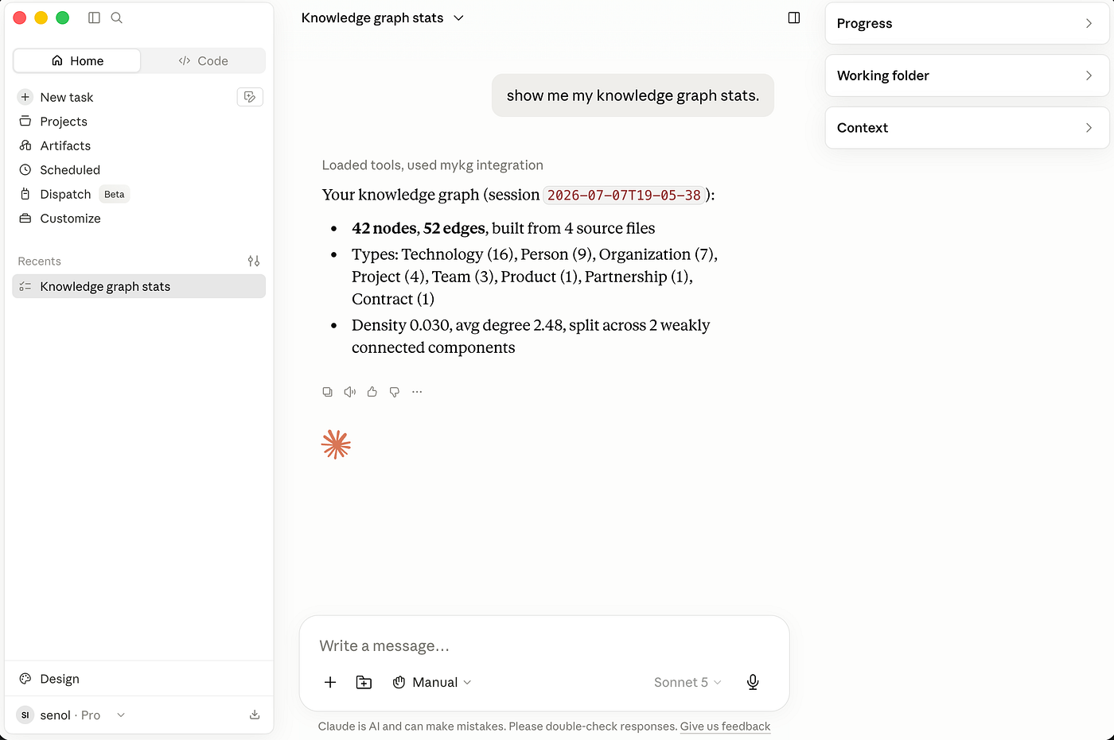
Before running a tool for the first time, Claude Desktop asks for your permission.
Press enter or click to view image in full size
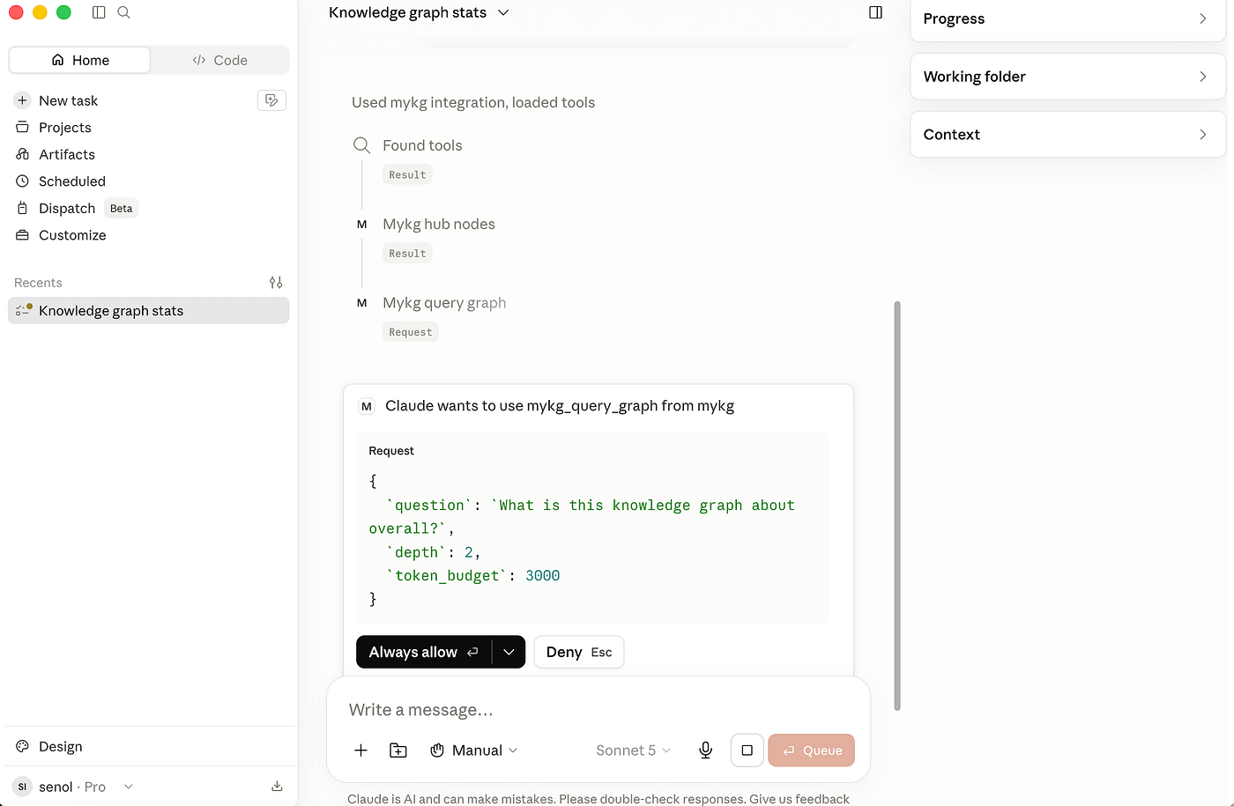
“Always allow” skips that prompt for future calls to the same tool. A broader, open-ended question triggers more of them at once:
Press enter or click to view image in full size

For this query, Claude chains several tools on its own, finding the most connected entities, querying for a graph-level answer, then reading Obsidian wiki notes a few times.
The result reads like a briefing:
Press enter or click to view image in full size
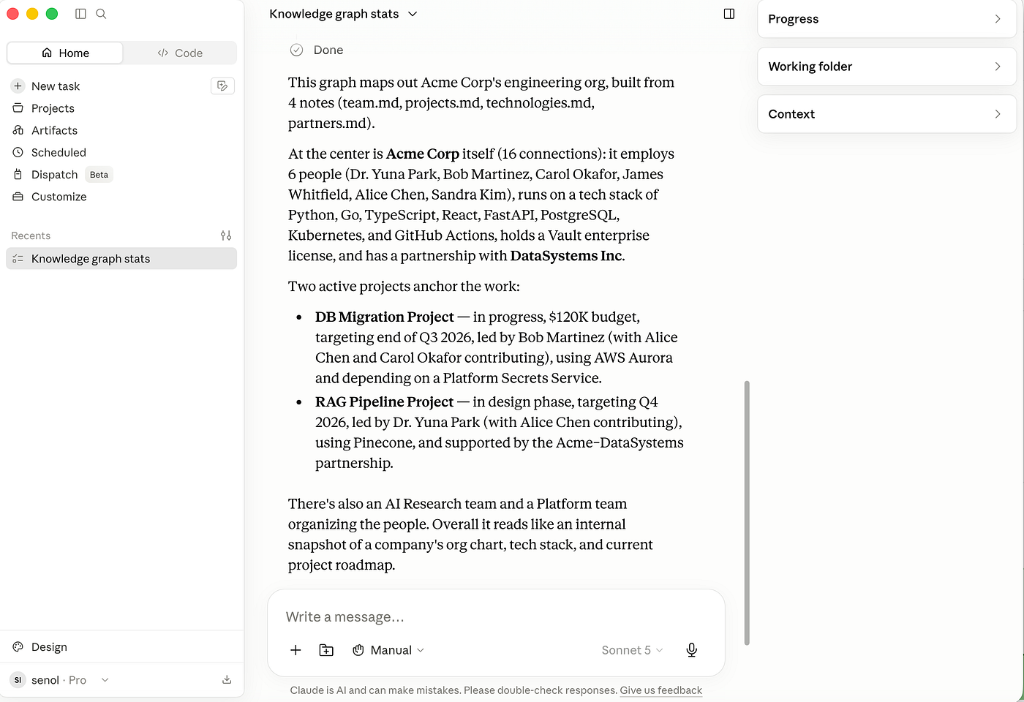
Asking Claude a more demanding and complex question, to “create the org chart of Acme Corp,” triggers 11 calls:
Press enter or click to view image in full size
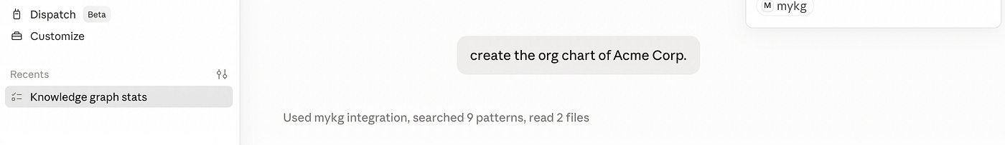
The resulting chart, and what Claude says about it, is worth reading closely:
Press enter or click to view image in full size
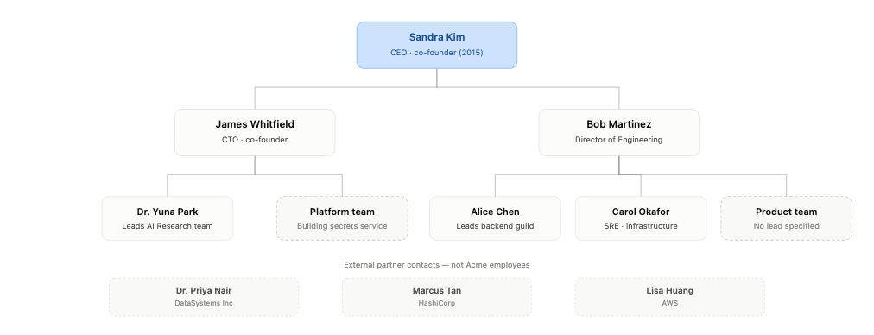
Press enter or click to view image in full size

This combination of using the graph to quickly discover the answer’s structure and verifying each claim against the source text is what makes the result trustworthy, not just fast.

Concluding remarks
myKG turns a folder of documents into a structured, queryable knowledge graph. This walkthrough covered the entire journey, from a fresh installation to connecting Claude Desktop and enabling it to chain tools against the graph.
A few files fit in a context window, but retrieval over hundreds of documents can miss connections spanning files that no single pass surfaces together. A graph has no such blind spot: its connections exist independently of source documents, allowing an AI agent to navigate the knowledge structure, discover relationships across the corpus, and reason over information that would otherwise remain scattered.

